Hey Victor,

Happy New Year and below are my updates while I have also attached the docs.

Kindly send me the contents for the image grid in the home page (fear won't let you rest, how intentional are you about living etc).

**Content included**

What kind of content do you have in mind for work with us?

**Attached the content for that as well, titled Connect & Work With Us**

For the careers page, do you intend to recruit people via it? If yes, what application method do you favour? **I have to rewrite the content for it and that will take some time so let’s take that out for now.**

Is the "word for today" page going to be dynamic, i.e will the contents change from time to time? Today’s WORDs in SEASON will have quotes in pictures

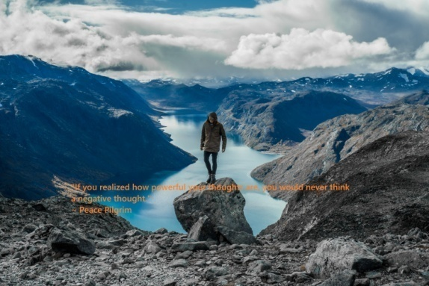 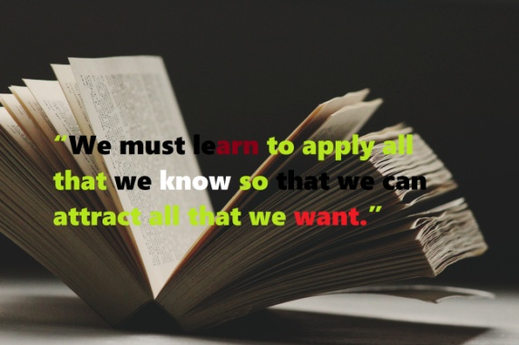

**To fully understand the concept: we will be sending out a weekly Newsletter and Today’s WORDs in SEASON once a week. Now if anyone visits the site, I want them to be able to download the Today’s WORDs in SEASON in pictures as our shareable images to share with their friends or use on their display photo.**

**The photo will have i. A Quote and ii. LIVINGANEFFECTIVELIFESTYLE.COM below**

I look forward to receiving your response soonest. I want to finish the site as soon as possible.